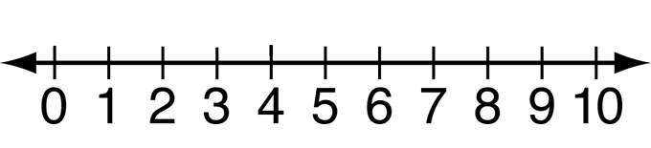

Number Line

Open Number Line

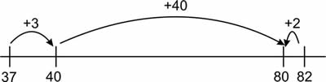

Unit 1

Unit 2

0

Double Number Line
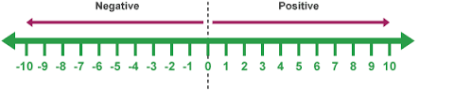
Number Line

